DarshanEase
Temple Darshan Ticket Booking System
1. INTRODUCTION
DarshanEase is a web-based application developed using the MERN Stack (MongoDB, Express.js, React.js, and Node.js). The main objective of this project is to provide a simple, secure, and user-friendly platform for booking temple darshan tickets online. Users can register, log in securely using JWT authentication, browse temples, select available darshan slots, book tickets, view booking history, and manage their profiles.
Temple organizers manage darshan slots and bookings, while administrators manage users, organizers, temples, and reports. The application provides a responsive interface developed using React.js, with Node.js and Express.js handling backend operations.
2. PROBLEM STATEMENT
Traditional temple darshan booking requires devotees to visit counters or rely on manual systems, which are time-consuming and inconvenient. Managing bookings manually may lead to delays, errors, and difficulty in tracking slot availability.
The objective of this project is to develop a secure and user-friendly online darshan booking system that allows devotees to register, log in, book slots, view booking history, and manage profiles. Organizers and administrators gain efficient tools to manage temples, slots, and reports.
3. OBJECTIVES
- Provide a simple and user-friendly online darshan booking platform.
- Allow users to register and log in securely using JWT authentication.
- Enable devotees to browse temples and book darshan slots.
- Allow users to view and manage their bookings.
- Provide organizers with slot management tools.
- Provide administrators with dashboards for managing users, temples, and reports.
- Store user and booking information securely in MongoDB Atlas.
4. SCOPE OF THE PROJECT
DarshanEase simplifies the darshan booking process through an online platform. Devotees can register, log in, and book slots from any location using a web browser. Organizers manage slots, while administrators oversee temples, users, and reports.
Future scope includes payment integration, mobile app support, and advanced analytics.
5. EXISTING SYSTEM
Manual booking involves queues, paperwork, and limited accessibility. Challenges include time wastage, lack of transparency, and poor scalability.
6. PROPOSED SYSTEM
DarshanEase provides an online platform for devotees and organizers. Features include slot booking, user management, and reporting. Secure JWT authentication, MongoDB Atlas database connectivity, and RESTful APIs ensure reliable performance.
7. SOFTWARE REQUIREMENTS
Software | Version/Tool
Operating System | Windows 10/11
Frontend | React.js (Vite)
Backend | Node.js, Express.js
Database | MongoDB Atlas
API Testing | Postman
Code Editor | Visual Studio Code
Browser | Google Chrome
Version Control | Git & GitHub
Runtime Environment | Node.js

8. HARDWARE REQUIREMENTS
Hardware | Specification
Processor | Intel Core i3 or above
RAM | 4 GB or above
Hard Disk | 20 GB Free Space
Internet | Required
Input | Standard Keyboard & Mouse
9. TECHNOLOGY STACK
The Temple Drashan Booking System is developed using the MERN Stack and related technologies.

Frontend
- React.js
- HTML5
- CSS3
- JavaScript

Backend
- Node.js
- Express.js

Database
- MongoDB Atlas

Authentication
- JSON Web Token (JWT)

Development Tools
- Visual Studio Code
- GitHub
- Postman
10. SYSTEM ARCHITECTURE
Three-tier architecture:
- Presentation Layer: React.js UI (Login, Temple List, Slot Booking, Profile, Admin Dashboard)
- Application Layer: Node.js, Express.js, REST APIs, JWT Authentication
- Database Layer: MongoDB Atlas (Users, Temples, Slots, Bookings)
11. DATABASE DESIGN
User Collection: _id, name, email, password, role Temple Collection: _id, name, location, description, organizerId Slot Collection: _id, templeId, date, time, capacity Booking Collection: _id, userId, slotId, status, createdAt
12. FRONTEND IMPLEMENTATION
Modules:
- Login/Register: Secure authentication with JWT.
- Temple List: Browse temples and slots.
- Book Slot: Select date/time and confirm booking.
- My Bookings: View and cancel bookings.
- Admin Dashboard: Manage users, temples, and reports.
13. BACKEND IMPLEMENTATION
- Server Configuration: Express.js setup, MongoDB Atlas connection, routes for authentication and booking.
- Authentication Routes: /register, /login
- Booking Routes: /book, /my/:userId, /cancel/:id, /accept/:id, /reject/:id, /all
- Controllers: Authentication Controller (register/login), Booking Controller (create/view/cancel/accept/reject bookings).
- Models: User, Temple, Slot, Booking.
- 14. API ENDPOINTS
Authentication APIs
Method | Endpoint | Description
POST | /api/auth/register | Register new user
POST | /api/auth/login | Login user
Booking APIs
Method | Endpoint | Description
POST | /api/booking/book | Book darshan slot
GET | /api/booking/my/:id | View user bookings
PUT | /api/booking/cancel/:id | Cancel booking
PUT | /api/booking/accept/:id | Accept booking
PUT | /api/booking/reject/:id | Reject booking
GET | /api/booking/all | View all bookings
15. PROJECT FOLDER STRUCTURE
cab-booking/
│
├── client/
│ ├── src/
│ │ ├── components/
│ │ ├── pages/
│ │ ├── services/
│ │ ├── App.jsx
│ │ └── main.jsx
│
├── server/
│ ├── controllers/
│ ├── middleware/
│ ├── models/
│ ├── routes/
│ ├── config/
│ ├── server.js
│ └── package.json│
└── README.md
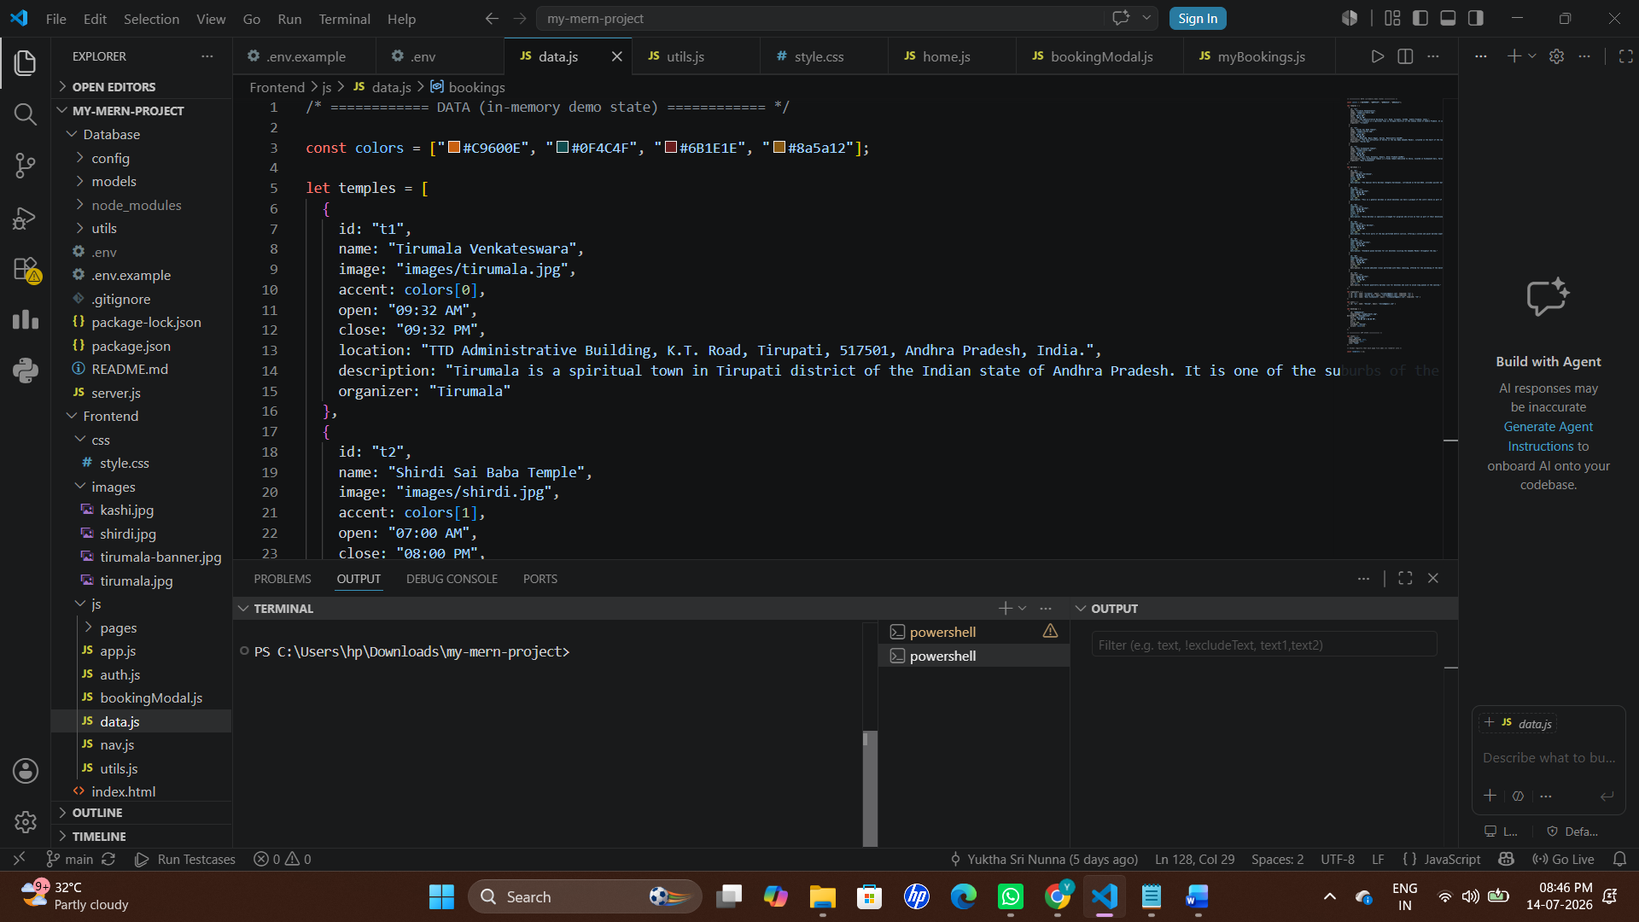

16. TESTING
Test Case | Expected Result | Status
User Registration | User registered successfully | Passed
User Login | Login successful | Passed
Book Slot | Booking created successfully | Passed
View My Bookings | Displays user bookings | Passed
Cancel Booking | Status changed to Cancelled | Passed
Organizer Accept Slot | Status changed to Accepted | Passed
Organizer Reject Slot | Status changed to Rejected | Passed

17. OUTPUT SCREENSHOTS
- Login Page
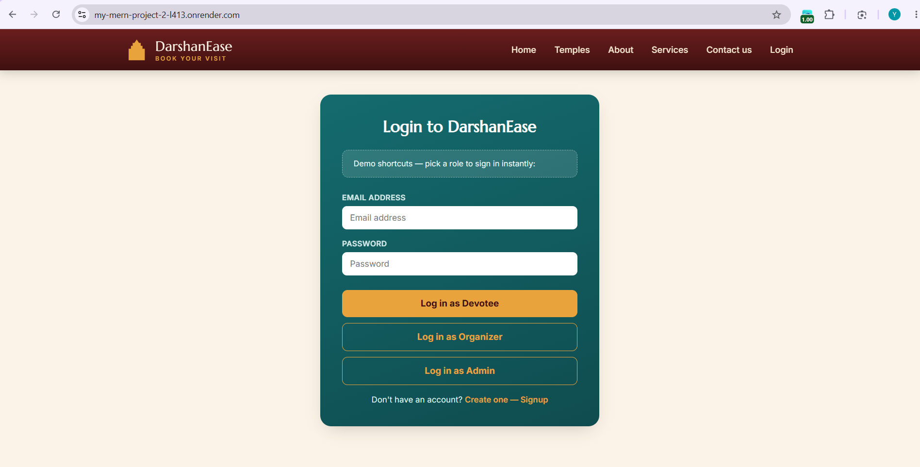
- Register Page
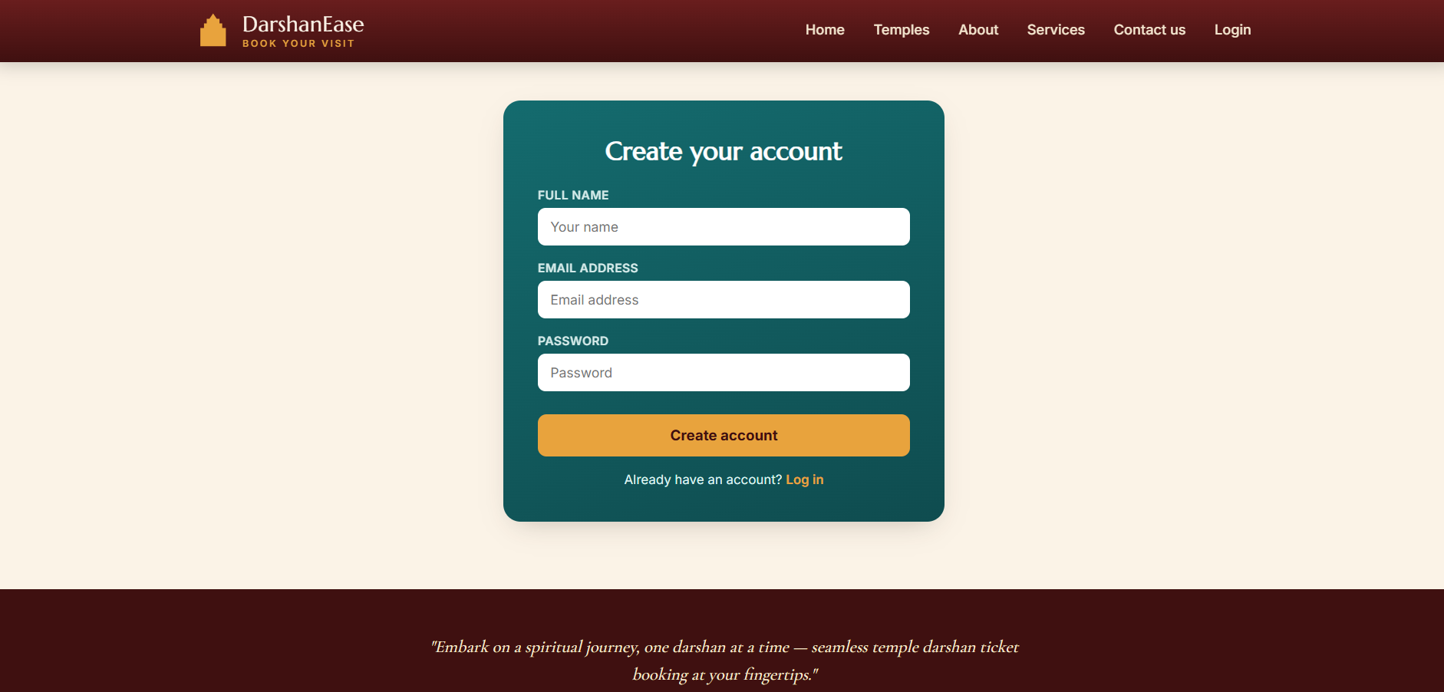
- Temple List Page
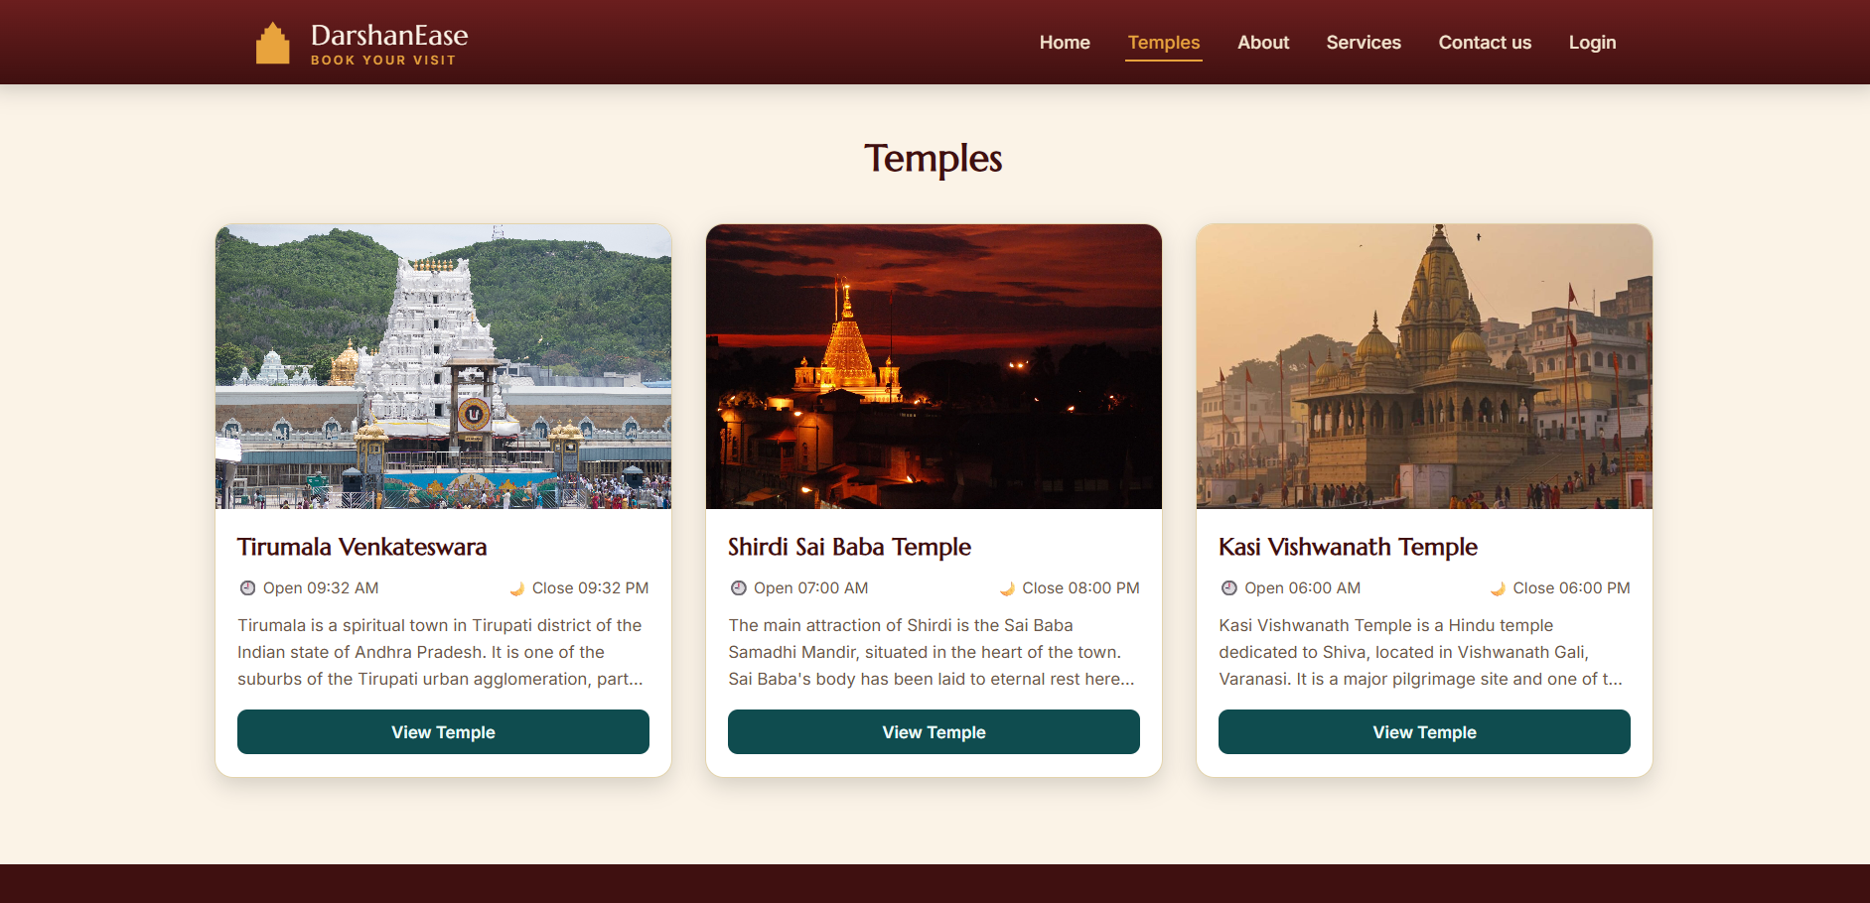
- Book Slot Page
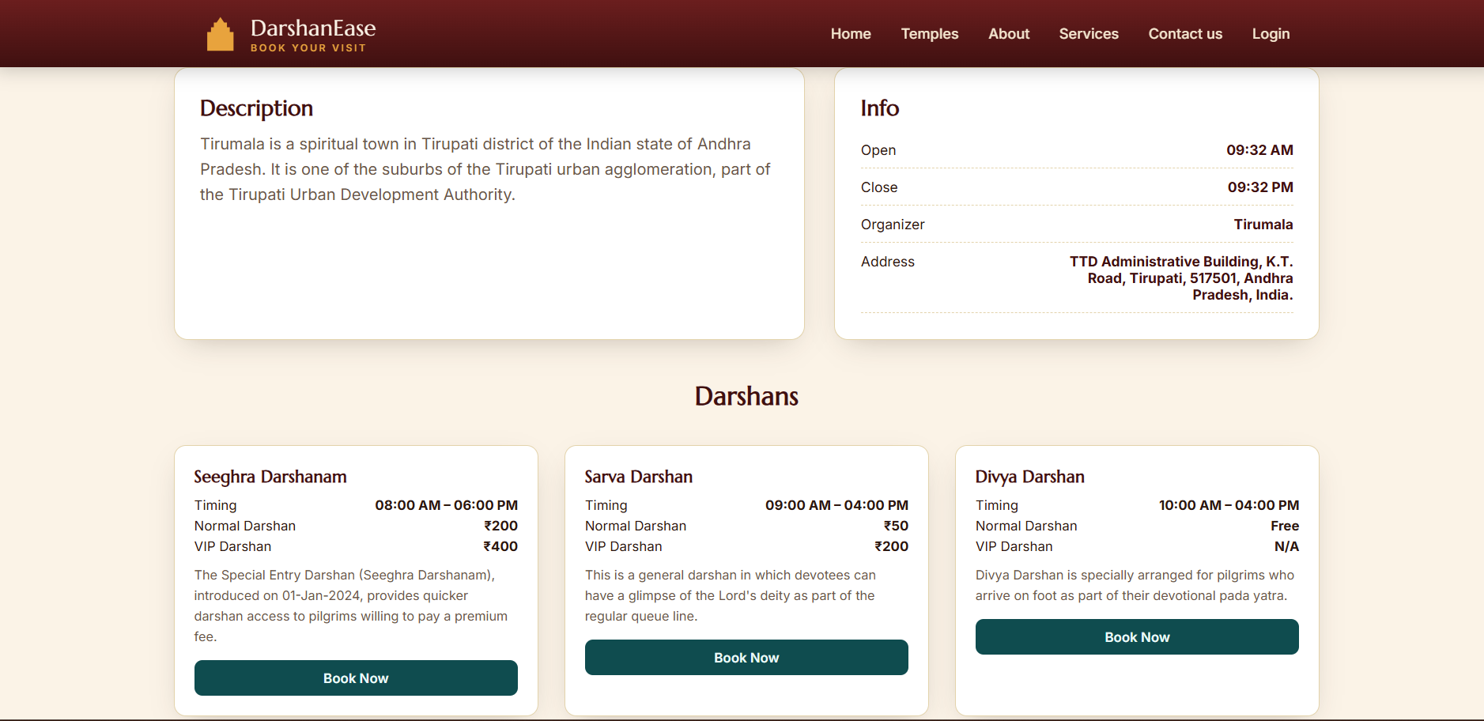
- My Bookings Page
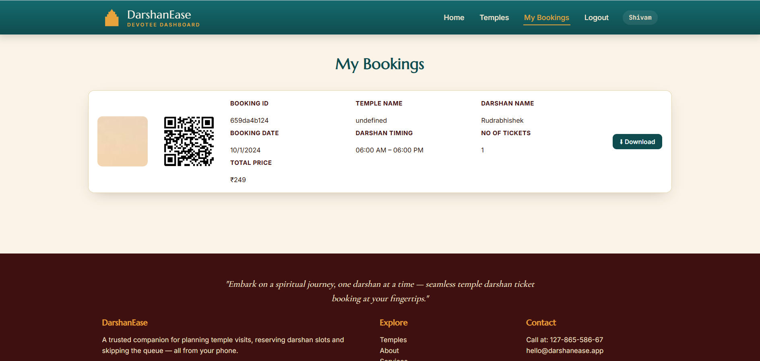

18. FUTURE ENHANCEMENTS
- Online payment integration
- Mobile app support
- Multi-language support
- Analytics dashboard
- SMS/Email notifications
19. CONCLUSION
DarshanEase is a full-stack web application developed using the MERN Stack. It provides a secure and efficient platform for online temple darshan booking with JWT authentication and MongoDB Atlas database connectivity. The project demonstrates full-stack development concepts, RESTful APIs, authentication, database management, and role-based access control.

